April 18th, 2024

**Comfort Airlines**

**Defect Log (Code + Documents)**

Client: Professor Michael Oudshoorn

Group Name: Byte Me

Contractors: Joellen A., Kyle B., Hanna Z., Alex H., Joshua T., JR V.

**About Defect Log**

The "Comfort Airlines Defect Log" document serves as a comprehensive record for tracking and managing various defects across software and documentation related to Comfort Airlines systems. Prepared by the Byte Me team, this document outlines identified defects in code and documentation, detailing their descriptions, defect numbers, contractors responsible, and resolutions. It functions as an essential tool for ensuring continuous quality improvement by documenting errors ranging from software crashes and operational inconsistencies to discrepancies in documentation requirements and integration issues. This meticulous approach helps the team in preventing future errors and enhancing the overall system performance.

**Defects in Requirements**

**File Name: Requirements_document.docx**

**Bug/ Defect Number:** 1

**Contractor:** Joellen Allah-Mensah

**Date of Defect:** February 13, 2024

**Time of Defect:** 9:05am

**Brief Defect Description:** found error in writing that the defect log was actually not supposed to be in this documentation as a deliverable

**Defect Address (Resolution Description):** To solve this problem, we removed the defect log from the requirements document, upon realizing that this is not what the client needs to see, as it is mainly for the company to keep track and log their mistakes to look back on it, and prevent any similar errors

**File Name: Minutes_of_Meetings.docx**

**Bug/ Defect Number:** 4

**Contractor:** Joellen Allah-Mensah

**Date:** February 16, 2024

**Time of Defect:** 2:05pm

**Defect Description:** In this file, our company made it rather vague, only putting the times and dates of the meetings, but not the members present at the meeting, or what we did

**Defect Address (Resolution Description):** To solve this problem, we updated the document to a chart, including a portion where we included the initials of the members present, and described the role of each member in specifics.

**File Name:** Database Airport

**Bug/ Defect Number:** 5

**Contractor:** JR Vano

**Date:** February 17, 2024

**Time of Defect:** 2:33pm

**Defect Description:** Realized the latitude and longitude for San Diego airport was incorrect

**Defect Address (Resolution Description):** Solved by changing the latitude and longitude were right as well as double checking every other airport to make sure they are all correct

**File Name:** Database Airport

**Bug/ Defect Number:** 6

**Contractor:** JR Vano

**Date:** February 17, 2024

**Time of Defect:** 2:34 pm

**Defect Description:** Wrong Great Circle Calculations due to wrong latitude and longitude for San Diego

**Defect Address (Resolution Description):** Recalculated every Great Circle Calculation for San Diego to every other airport.

**File Name: Flight_Routes_and_Airplane_Type.docx**

**Bug/ Defect Number:** 10

**Contractor:** JR Vano

**Date:** March 17, 2024

**Time of Defect:** 2:30pm

**Defect Description:** Found error where one of the planned flight routes was too short based on the project requirements.

**Defect Address (Resolution Description):** Solved by changing the planned flight route for a different flight route that fit the distance requirements.

**File Name: Defect_Log.docx**

**Bug/ Defect Number:** 15

**Contractor:** Joellen Allah-Mensah

**Date:** March 17, 2024

**Time of Defect:** 2:48pm

**Defect Description:** In this file, our company initially failed to include the defect number, as well as time of defect in this log.

**Defect Address (Resolution Description):** To solve this problem, we updated the document to include the missing elements so that the client had knowledge of the time this defect took place, as well as how many defects we had.

**File Name: Minutes_of_Meetings.docx**

**Bug/ Defect Number:** 23

**Contractor:** Hanna Zelis

**Date of Defect:** March 22, 2024

**Time of Defect:** 7:51am

**Brief Defect Description:** In this file, it lacked the inclusion of a discussion as well as decisions reached and the alternatives to those decisions that were discussed

**Defect Address (Resolution Description):** To solve this problem, we reformatted the document to an outline form and generated a bullet point for discussion where we described what conversation occurred at that meeting

**File Name: Minutes_of_Meetings.docx**

**Bug/ Defect Number:** 24

**Contractor:** Hanna Zelis

**Date of Defect:** March 22, 2024

**Time of Defect:** 7:55am

**Brief Defect Description:** In this file, it was not as detailed about the work assigned as there were no assigned due dates, with the details including a necessary progress report

**Defect Address (Resolution Description):** To solve this problem, we reformatted the document to an outline form and rewrote out the work assigned each week towards the end of the notes per each meeting in addition to adding the due date in parentheses after each person’s assigned job, which were typically the following week.

**File Name: Minutes_of_Meetings.docx**

**Bug/ Defect Number:** 25

**Contractor:** Hanna Zelis

**Date of Defect:** March 22, 2024

**Time of Defect:** 8:15am

**Brief Defect Description:** In this file, it lacked the inclusion of a project report, which is how the development of each person’s assigned work leading up to the due date

**Defect Address (Resolution Description):** To solve this problem, we reformatted the document to an outline form and wrote out a project report under each week’s assigned work for each person and had each person fill in whether or not they were able to complete the assignment with ease or if they had some struggles or bugs and needed help or could not figure out how to complete their assigned worked by the due date

**File Name:** defect log

**Bug/ Defect Number:** 44

**Contractor:** Hanna Zelis

**Date:** April 14, 2024

**Time of Defect:** 2:10 pm

**Defect Description:** The bug/defect numbers were all off, with there being some duplicates, some numbers missing, and others just simply out of timeline order

**Defect Address (Resolution Description):** I printed out the defect log and walked through each defect, re-numbering about 39 of the 43 numbers that were off. Now the problem is all fixed and people in the group know that they need to keep a close eye out for the numbers so we don’t have to do the tedious work again.

**File Name:** Time Management Document

**Bug/ Defect Number:** 53

**Contractor:** Hanna Zelis

**Date:** April 14, 2024

**Time of Defect:** 7:56pm

**Defect Description:** The time management document was reported as unhelpful after checkpoint three

**Defect Address (Resolution Description):** Because of this, we are redirecting the software from Lucid to SmartSheet, getting everyone to rewrite in further detail their tasks

**File Name:** Requirements Document / GUI

**Bug/ Defect Number:** 54

**Contractor:** Hanna Zelis

**Date:**April 14, 2024

**Time of Defect:** 8:04pm

**Defect Description:** The GUI display photos of the prototypes in the document were claimed that they could not be found, though they were in the GUI documentation. We believe they were not found as they were not in one of the original documents that are on the project.pdf that are required to be turned in.

**Defect Address (Resolution Description):** We transferred the GUI documentation to the requirements document to ensure that not only the display of screenshots of the GUI will be seen, but also the information regarding the GUI will be as well, as that is the big component showing all pieces and parts of our final project.

**File Name:** Minutes of Meetings

**Bug/ Defect Number:** 57

**Contractor:** Hanna Zelis

**Date:** April 14, 2024

**Time of Defect:** 8:43pm

**Defect Description:** The minutes of meetings were reported as difficult to scroll through due to the older meetings being at the top of the document and the newer meetings being at the bottom, ultimately making it confusing when reading through the entire document.

**Defect Address (Resolution Description):** To make this easier for the client, the solution to this defect was to rotate all of the minutes of meetings to have the newest meetings at the top and put the older meetings (from the beginning of the semester) at the bottom of the document.

**File Name:** Requirements Document / Requirements Document / User Manual

**Bug/ Defect Number:** 59

**Contractor:** Hanna Zelis

**Date:** April 14, 2024

**Time of Defect:** 9:04pm

**Defect Description:** If the GUI documentation was at risk not being seen, there is a chance the docker setup/documentation was not noticed, so part of this means to adjust to the requirements document and user manual as necessary.

**Defect Address (Resolution Description):** Moving the parts of the docker set up to the user manual and the general gist of the docker to the requirements document so the user has what is necessary in the user set up and knows the information behind the docker in the requirements document.

**File Name:** Requirements Document

**Bug/ Defect Number:** 85

**Contractor:** JR Vano

**Date:** April 16, 2024

**Time of Defect:** 11:36 am

**Defect Description:** Missing Aircraft Boeing 747-400 under Airplane Decisions: All-First Class vs Mix-Class

**Defect Address (Resolution Description):** Added our details that describes the changes made to the seats in the plane.

**File Name:** Requirements Document

**Bug/ Defect Number:** 84

**Contractor:** JR Vano

**Date:** April 16, 2024

**Time of Defect:** 11:33 am

**Defect Description:** Missing Information under Non-Functional Requirements

**Defect Address (Resolution Description):** Added Presentation for a folder shared in google drive

**File Name: route.php**

**Bug/ Defect Number:** 88

**Contractor:** Kyle Boan

**Date:** April 16, 2024

**Time of Defect:** 2:19 PM

**Defect Description:** Missing header information

**Defect Address (Resolution Description):** Added header information

**File Name: profit_loss_calculation.cpp**

**Bug/ Defect Number:** 89

**Contractor:** Kyle Boan

**Date:** April 16, 2024

**Time of Defect:** 2:19 PM

**Defect Description:** Missing header information

**Defect Address (Resolution Description):** Added header information

**File Name: index.php**

**Bug/ Defect Number:** 90

**Contractor:** Kyle Boan

**Date:** April 16, 2024

**Time of Defect:** 2:19 PM

**Defect Description:** Missing header information

**Defect Address (Resolution Description):** Added header information

**File Name: confort-connect.php**

**Bug/ Defect Number:** 91

**Contractor:** Kyle Boan

**Date:** April 16, 2024

**Time of Defect:** 2:19 PM

**Defect Description:** Missing header information

**Defect Address (Resolution Description):** Added header information

**File Name:** User Manual

**Bug/ Defect Number:** 93

**Contractor:** Joshua Thompson

**Date:** April 16, 2024

**Time of Defect:** 6:23 PM

**Defect Description:** The user manual was in desperate need of being updated, with most if not all of the information being out of date and, at the point of finding the defect, completely inaccurate.

**Defect Address (Resolution Description):** Went back through and updated the defect log to make sure that everything is up to date.

**File Name:** Functional Specification

**Bug/ Defect Number:** 94

**Contractor:** JR Vano

**Date:** April 17, 2024

**Time of Defect:** 2:10 pm

**Defect Description:** Missing output on functional specification document for passengerDensity.cpp

**Defect Address (Resolution Description):** Added output for functional specification document

**File Name:** Functional Specification

**Bug/ Defect Number:** 95

**Contractor:** JR Vano

**Date:** April 17, 2024

**Time of Defect:** 2:13 pm

**Defect Description:** Missing output on functional specification document for flightTime.cpp

**Defect Address (Resolution Description):** Added output in function specification document

**Defects in Code**

**File Name: Swing_Applet.java**

**Bug/ Defect Number:** 2

**Contractor:** Joellen Allah-Mensah

**Date:** February 13, 2024

**Time of Defect:** 11:10am

**Defect Description:** When trying to get java file to work when connecting to database, the string command failed to connect the database to the java program

**Defect Address (Resolution Description):** Removed the use Java GUI entirely, switched to PHP and HTML, which we were able to connect the database successfully

**Code:**

String url = "jdbc:mariadb://localhost:3306/comfort_airlines_byteme";

**File Name: comfort_db.php**

**Bug/ Defect Number:** 3

**Contractor:** Joellen Allah-Mensah

**Date:** February 15, 2024

**Time of Defect:** 3:07pm

**Defect Description:** When trying to link the database to the HTML file with PHP, I incorrectly typed in the connection to joecool instead of mariadb, so it was linking to the incorrect account.

**Defect Address (Resolution Description):** To fix it, we switch it to the following correct code below, linking the PHP with the mariadb database with the right variable assignments:

**Code:**

<?php

$dsn = 'mysql:host=joecool.highpoint.edu;dbname=comfort_airlines_byteme';

$username = 'jallah';

$password = '1824500';

$dsn = 'mariadb:host=localhost;port=3306;dbname=comfort_airlines_byteme';

$username = 'joellenallah-mensah';

$password = '********';

**File Name: flightTime.cpp**

**Bug/ Defect Number:** 16

**Contractor:** Kyle Boan

**Date:** March 18, 2024

**Time of Defect:** 2:45pm

**Defect Description:** When writing the file I filled the structs with temporary data that is not correct for the project.

**Defect Address (Resolution Description):** To fix code needs to be added to auto fill the structs with the correct data from the database when the function/file is called.

**Code:**

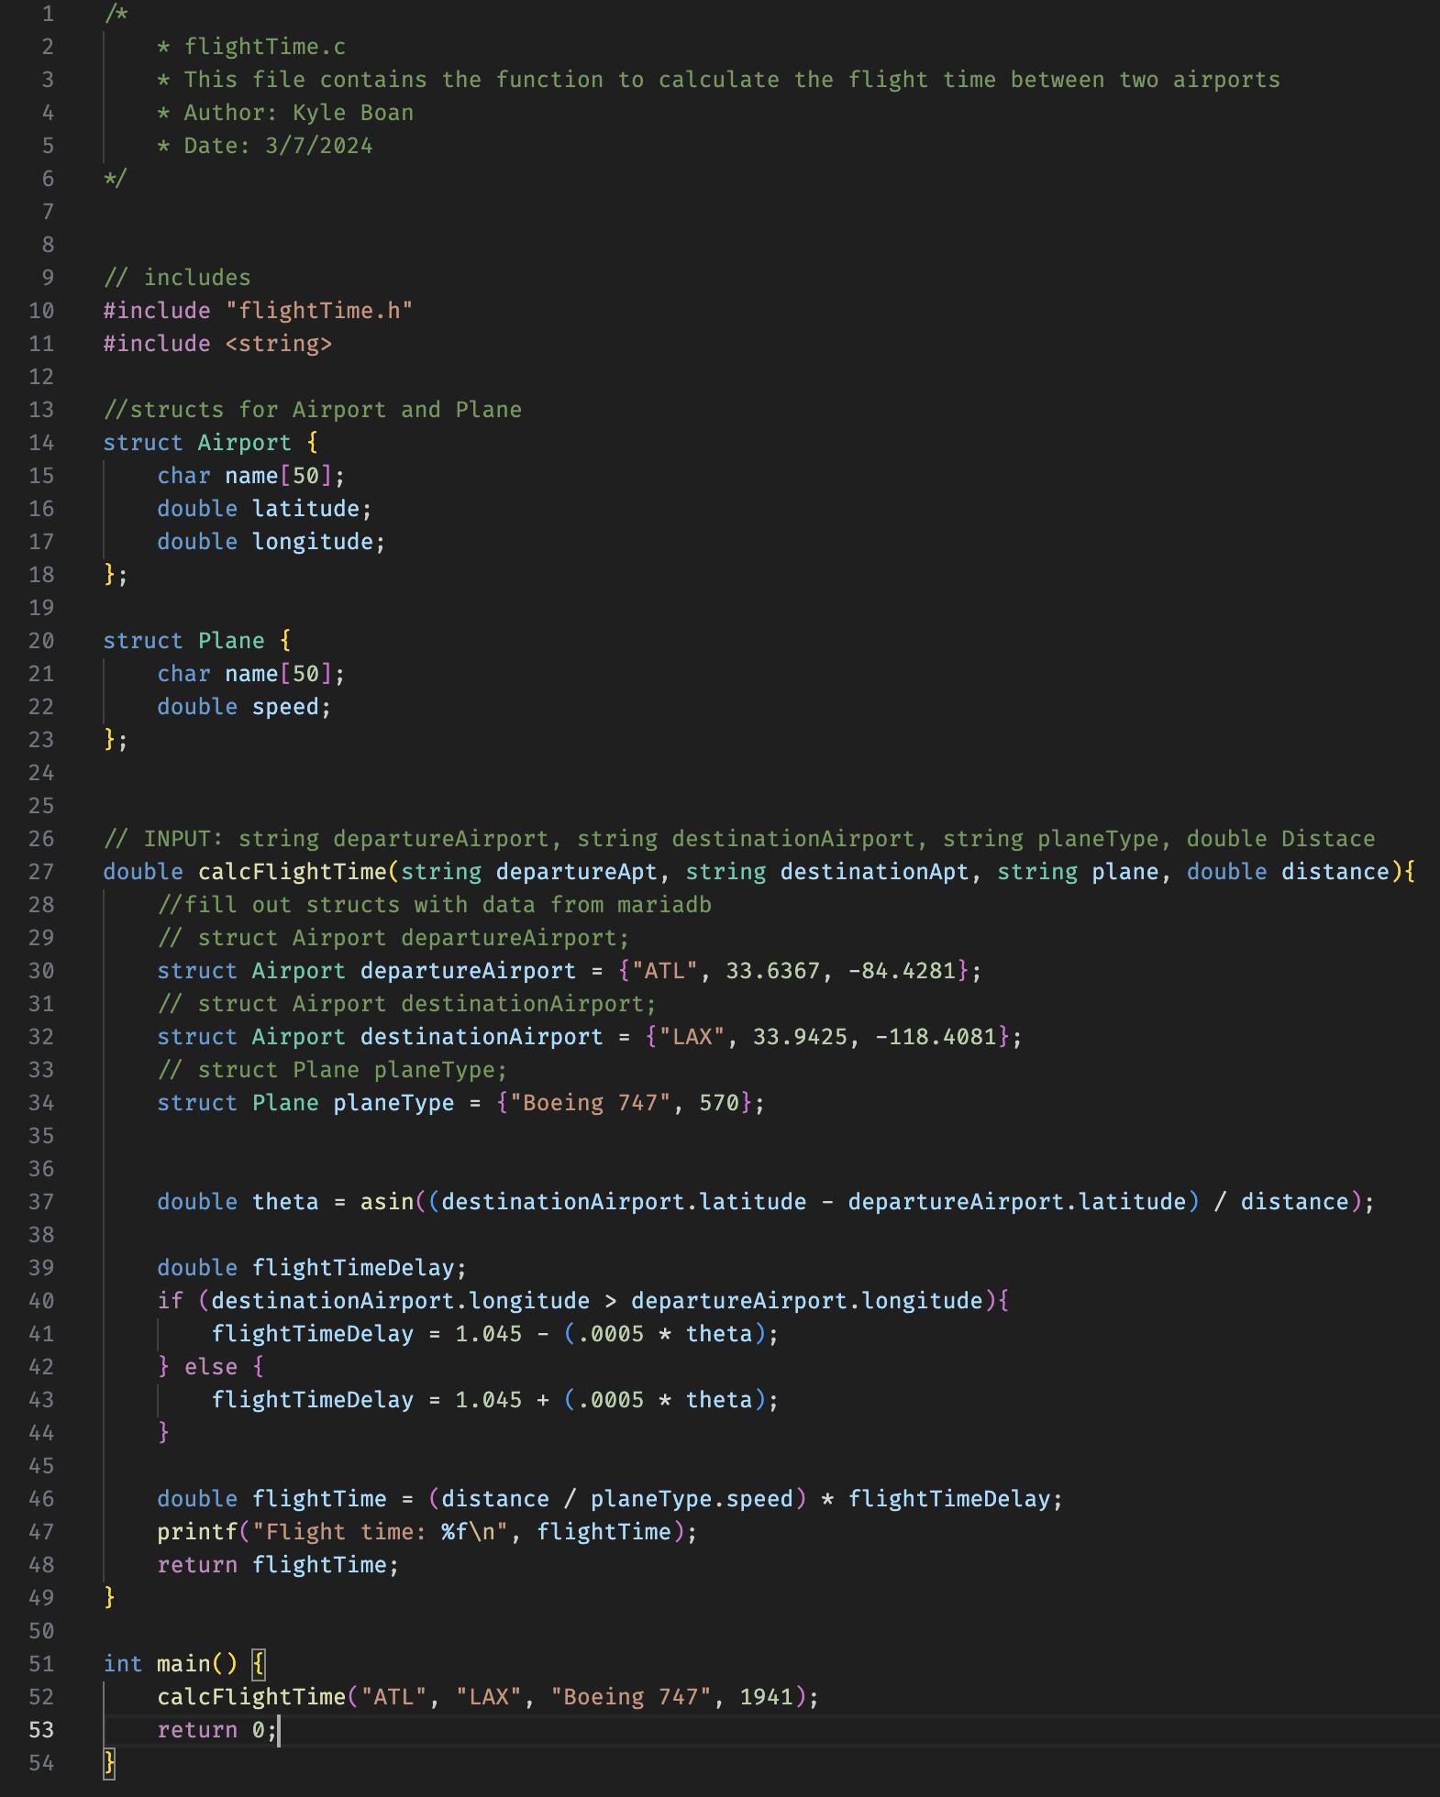

**File Name: calc.php**

**Bug/ Defect Number:** 5

**Contractor:** Joellen Allah-Mensah

**Date:** March 1, 2024

**Time of Defect:** 3:44pm

**Defect Description:** GUI page kept crashing because I implemented the PHP file before we had flights stored in database for testing. There was no way to test GUI without flights stored in DB, needed a way to test around this issue.

**Defect Address (Resolution Description):** Included an if else statement that echoed a statement if there was no flights found, instead of defaulting to a “page not working” url, while still processing the flights, even if there are none in the DB.

**Code:**

if (!empty($flights)) {

foreach ($flights as $flight) {

// Process each flight

}

} else {

echo "No flights found.";

}

**File Name: calc.php**

**Bug/ Defect Number:** 11

**Contractor:** Joellen Allah-Mensah

**Date:** March 14, 2024

**Time of Defect:** 6:44pm

**Defect Description:** In this defect, I was having a difficult time figuring out what was wrong with my php, since PHP is a language that does not output errors via terminal with a compilation command, we could not figure out why it the functions would not output.

**Defect Address (Resolution Description):** To solve this, we echoed the debugging to the HTML page on top of the page content so that it would tell us what was wrong, as well as what data from the DB was currently being processed at the time. This helped us figure out what needed changing within our code.

**Code:**

echo "<pre>Leasing Fees Per Day: ";

print_r($leasingFeesPerDay);

echo "</pre>";

**File Name: calc.php**

**Bug/ Defect Number:** 12

**Contractor:** Joellen Allah-Mensah

**Date:** March 14, 2024

**Time of Defect:** 10:37 am

**Defect Description:** In this defect, when we want to get the sum of the flights pricings per day depending on their aircraft, we tried cycling through the dates of each flight, but it would not grab the first date of flights based on the range of flying days we initially set.

**Defect Address (Resolution Description):** To solve this, we added a “+1” to ensure that the counting started from day 1, instead of the previous day, so that the first day would be counted within the array

**Code:**

foreach ($flights as $flight) {

$flightDate = new DateTime($flight['FlightDate']);

$dayNumber = $earliestDate->diff($flightDate)->days + 1; // +1 to start counting from day 1

**File Name: calc.php**

**Bug/ Defect Number:** 14

**Contractor:** Joellen Allah-Mensah

**Date:** March 15, 2024

**Time of Defect:** 12:55 pm

**Defect Description:** In this defect, I had issues trying to abstract the first two numbers of the flights assigned tailnumber in order to assign it to a boeing, which would then be assigned to a price.

**Defect Address (Resolution Description):** To solve this, I utilized the explode function, which breaks the strings into an array, and from the array, grabs the first two characters in the array, so that we could assign it to the boeing based on the prefixes.

**Code:**

foreach ($flights as $flight) {

$prefix = explode('-', $flight['TailNumber'])[0];

$FlightDate = new DateTime($flight['FlightDate']);

$leasingRate = $leasingRates[$prefix] ?? 0;

**File Name: calc.php**

**Bug/ Defect Number:** 13

**Contractor:** Alexandra Hall

**Date:** March 14, 2024

**Time of Defect:** 4:34 pm

**Defect Description:** Our initial boeing did not contain a dash, which made it more difficult to grab the first two characters in the tailnumber.

**Defect Address (Resolution Description):** To solve this, we added a dash between each tailnumber so that it would be easier to grab the aircraft specification before the individual tailNumbers so it would be easier to assign them specific prices.

**From the Database:**

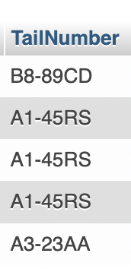

**File Name:** docker-compose.yml

**Bug/ Defect Number:** 17

**Contractor:** Joshua Thompson

**Date:** March 18, 2024

**Time of Defect:** 3:30pm

**Defect Description:** Database won't connect to the docker properly.

**Defect Address (Resolution Description):**

Resolved, the ports were an issue, now allowing the containers to properly communicate

**File Name: Comfort_airlines_byteme Database**

**Bug/ Defect Number:** 6

**Contractor:** Alexandra Hall

**Date:** March 10, 2024

**Time of Defect:** 3:45pm

**Defect Description:** The database lacked a section for distance that was needed for the GUI to perform all necessary tasks.

**Defect Address (Resolution Description):** Made a column in the database within the flights table for distance. That table was chosen so that each flight from one location to another could be linked with distance. Once that was done each flight can be put into a section of code and edited for any delays.

**From the Database:(with example data)**

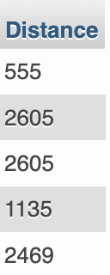

**File Name: Comfort_airlines_byteme Database**

**Bug/ Defect Number:** 7

**Contractor:** Alexandra Hall

**Date:**  March 10, 2024

**Time of Defect:** 2:03pm

**Defect Description:** Could not calculate correct speed with direction affecting it.

**Defect Address (Resolution Description):**Needed to add latitude and longitude to correctly calculate location and speed

**From the Database:**

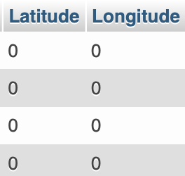

**File Name: dockerfile**

**Bug/ Defect Number:** 18

**Contractor:** Joshua Thompson

**Date: 03/20/2024**

**Time of Defect:** 6:24pm

**Defect Description:** The php code refuses to update despite killing and relaunching the container

**Defect Address (Resolution Description):** the command we were trying to use was incorrectly configured.

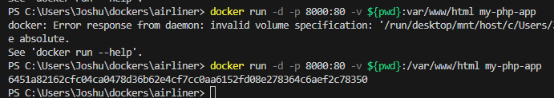

**File Name: docker desktop**

**Bug/ Defect Number:** 19

**Contractor:** Joshua Thompson

**Date:** March 20, **2024**

**Time of Defect:** 6:37pm

**Defect Description:** Docker desktop occasionally crashes upon launch of multiple containers, usually at around 15 minutes.

**Defect Address (Resolution Description):**

Still resolving

**File Name: Comfort_airlines_byteme Database**

**Bug/ Defect Number:** 8

**Contractor:** Alexandra Hall

**Date:** March 10, 2024

**Time of Defect:** 3:12

**Defect Description:** Could not use the speed variable in the code

**Defect Address (Resolution Description):** Added Speed section to aircraft table for calculations.

**From the Database:**

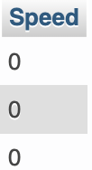

**File Name: Index.php**

**Bug/ Defect Number:** 9

**Contractor:** Joellen Allah-Mensah

**Date:** March 11, 2024

**Time of Defect:** 3:55pm

**Defect Description:** Could not get the query to connect to the airport code due to order of the SELECT command.

**Defect Address (Resolution Description):** Reordered the code, so that the SELECT AirportCode comes before the ORDER BY command, successfully pulls data and outputs to GUI.

**Code:**

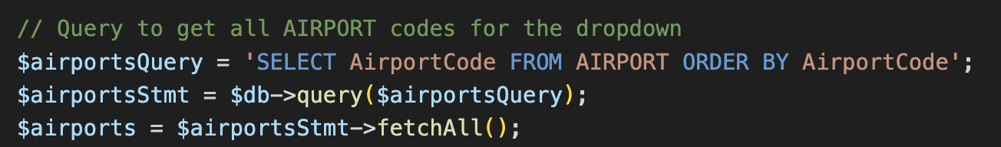

**File Name: Index.php**

**Bug/ Defect Number:** 20

**Contractor:**  Joellen Allah-Mensah

**Date:** March 20, 2024

**Time of Defect:**  5:03pm

**Defect Description:** Dropdown did not work because I was not using the isset function, and just assigned the selectedAirportcode to the post command.

**Defect Address (Resolution Description):** I invoked the “isset” command, which used to determine whether a variable is set or not.

**Code:**

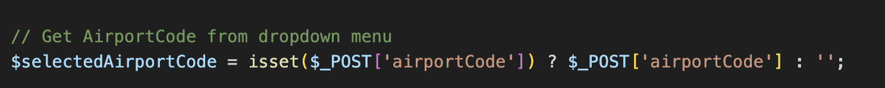

**File Name: flightTime.cpp**

**Bug/ Defect Number:** 21

**Contractor:** Kyle Boan

**Date:** March 21, 2024

**Time of Defect:** 8:02pm

**Defect Description:**  Trouble connecting cpp file to database.

**Defect Address (Resolution Description):** Change function to receive data as function parameters rather than retrieve data from database in file.

**Code:**

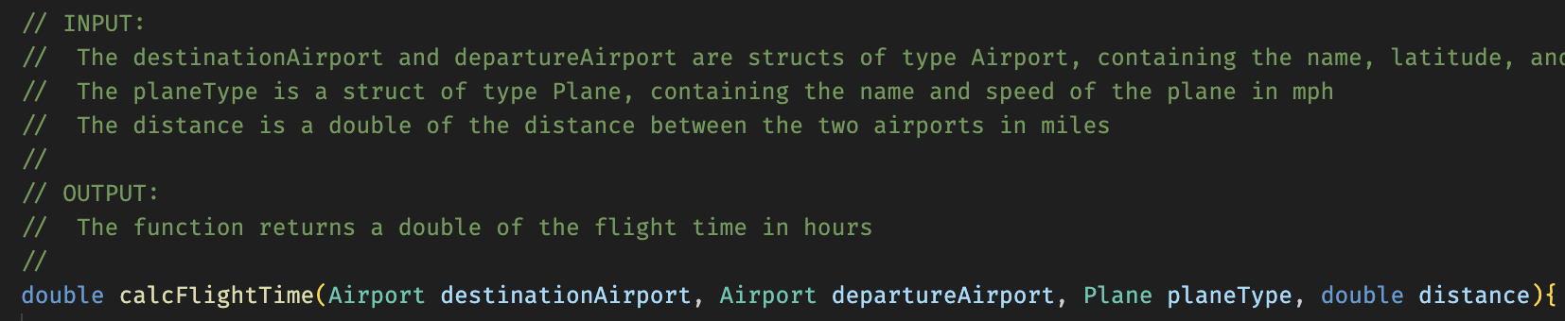

**File Name: flightTime.h**

**Bug/ Defect Number:** 22

**Contractor:** Kyle Boan

**Date:** March 21, 2024

**Time of Defect:** 8:02pm

**Defect Description:**  Reference defect number 21. Need to change header file to reflect changes to flightTime.cpp.

**Defect Address (Resolution Description):** Changed calcFlightTime() header to reflect changes made in flightTime.cpp.

**Code:**

**File Name: Database Flight Table**

**Bug/ Defect Number:** 27

**Contractor:** Joshua Thompson

**Date:** April 2, 2024

**Time of Defect:** 5:48pm

**Defect Description:**  We briefly considered a delay of takeoff and a delay in the air to be the same thing in our tables.

**Defect Address (Resolution Description):** We quickly noticed the issue and rectified it before it grew out of hand, now our database reflects delays on the ground and in the air.

**File Name: Database Flight Table**

**Bug/ Defect Number:** 28

**Contractor:** Joshua Thompson

**Date:** April 10, 2024

**Time of Defect:** 3:25pm

**Defect Description:**  One of our routes had an incorrect time listed. Changing time zones an hour was added instead of removed

**Defect Address (Resolution Description):** I corrected the flight table and propagated the change to every other flight across the two weeks.

**File Name: Database Flight Table**

**Bug/ Defect Number:** 39

**Contractor:** Alexandra Hall

**Date:** April 11, 2024

**Time of Defect:** 5:15pm

**Defect Description:** time on flights for day 13 were off by a few hours

**Defect Address (Resolution Description):** recalculated the flight time and gate to gate time

**File Name: index.php**

**Bug/ Defect Number:** 40

**Contractor:** Kyle Boan

**Date:** April 12, 2024

**Time of Defect:** 2pm

**Defect Description:**  the gui was not updating after pushing it to others.

**Defect Address (Resolution Description):** We discovered that we ran the docker, changed the database, then pushed it. This caused the gui to look different despite seemingly having the same code and database. We corrected the issue by fixing the database and restarting all the dockers.

**File Name: Database Passenger Data**

**Bug/ Defect Number:** 41

**Contractor:** Alexandra Hall

**Date:** April 13, 2024

**Time of Defect:** 12:30pm

**Defect Description:** script for passenger file would not compile

**Defect Address (Resolution Description):** changed the compiler on VS code and was able to9 run it efficiently

**File Name: Database Passenger Table**

**Bug/ Defect Number:** 42

**Contractor:** Alexandra Hall

**Date:** April 14, 2024

**Time of Defect:** 3:14am

**Defect Description:** script would not run file

**Defect Address (Resolution Description):** had to make java code to run added file

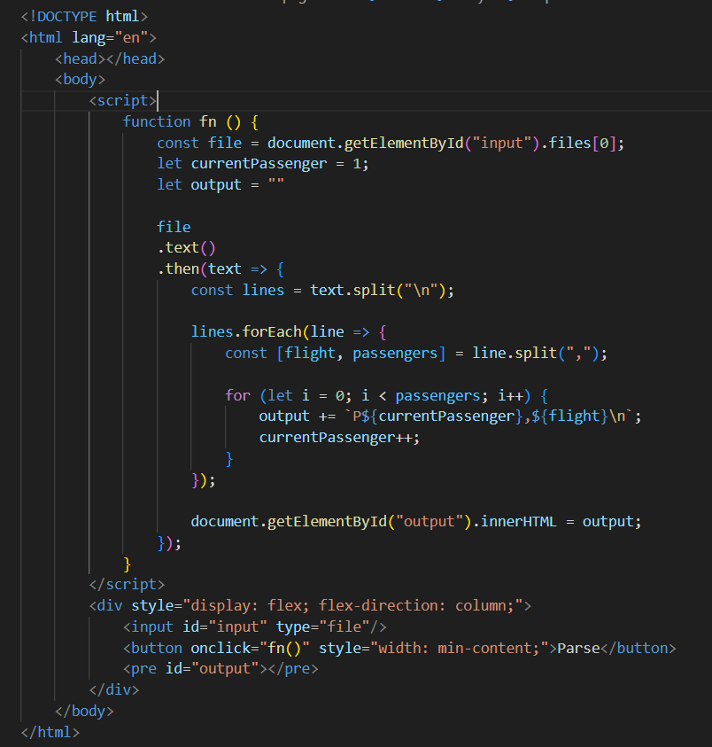

**File Name: Database Airport Table**

**Bug/ Defect Number:** 26

**Contractor:** Alexandra Hall

**Date:** April 1, 2024

**Time of Defect:** 8:50pm

**Defect Description:** airport table could not fit all data from every flight in it

**Defect Address (Resolution Description):** Airport table could not have a flight number column

**File Name: Database Airport Table**

**Bug/ Defect Number:** 29

**Contractor:** Alexandra Hall

**Date:** April 10, 2024

**Time of Defect:** 3:25pm

**Defect Description:** airport table was not working with the other tables planing

**Defect Address (Resolution Description):** dates removed from airport database

**File Name: Database Flight Table**

**Bug/ Defect Number:** 43

**Contractor:** Alexandra Hall

**Date:** April 14, 2024

**Time of Defect:** 5:00am

**Defect Description:** database checking and error correction

**Defect Address (Resolution Description):** fixed errors found in flight table code

**File Name: Database Flight Table**

**Bug/ Defect Number:** 30

**Contractor:** Alexandra Hall

**Date:** April 10, 2024

**Time of Defect:** 3:25pm

**Defect Description:**

| F206B | R25 | SLC | DFW | 9:23 PM | 12:32 AM | 0:00:00 | 0:00:00 | 2024-08-03 | 2024-08-04 | AB3-22 | 7 | 0 | 3 | 0 |  |  |  |  |  |  |  |  |  |  |  |  |  |  |
| --- | --- | --- | --- | --- | --- | --- | --- | --- | --- | --- | --- | --- | --- | --- | --- | --- | --- | --- | --- | --- | --- | --- | --- | --- | --- | --- | --- | --- |

Canceled flights had data that would not be used

**Defect Address (Resolution Description):** Changed value of canceled flight as to not be included in calculations

**File Name: Database Flight Table**

**Bug/ Defect Number:** 31

**Contractor:** Alexandra Hall

**Date:** April 10, 2024

**Time of Defect:** 8:25pm

**Defect Description:** Flight table passenger sum was off by a large portion, script was outputting wrong numbers

**Defect Address (Resolution Description):** changed a line that had the sum of all passengers thawing off the total number of passengers by double

**File Name: Database Flight Table**

**Bug/ Defect Number:** 32

**Contractor:** Alexandra Hall

**Date:** April 10, 2024

**Time of Defect:** 1:25pm

**Defect Description:** Docker would not run on certain laptops

**Defect Address (Resolution Description):** delete and update docker to current version and run it again, took several minutes to open.

**File Name: Database Flight Table**

**Bug/ Defect Number:** 33

**Contractor:** Alexandra Hall

**Date:** April 10, 2024

**Time of Defect:** 3:25pm

**Defect Description:** docker would not open localhost database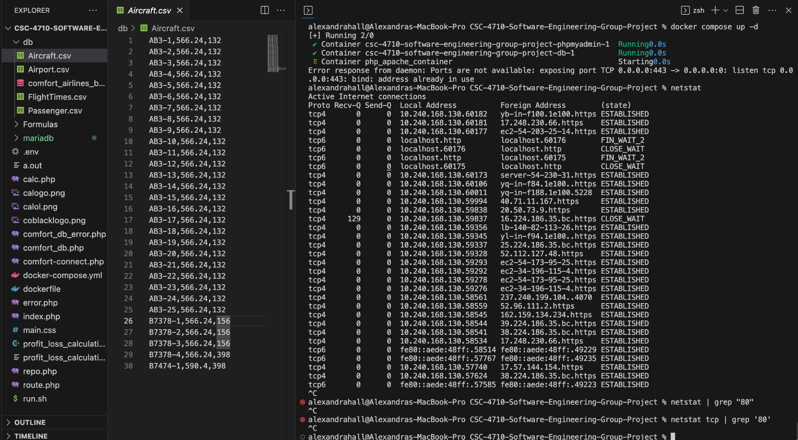

**Defect Address (Resolution Description):** had to delete the previous version and other containers. Did /run.sh to keep the docker updated and running.

**File Name: Database Flight Table**

**Bug/ Defect Number:** 34

**Contractor:** Alexandra Hall

**Date:** April 10, 2024

**Time of Defect:** 3:25pm

**Defect Description:** Docker push and pull would not grab correct file

**Defect Address (Resolution Description):** updated github with correct files so code could be ran.

**File Name: Database Flight Table**

**Bug/ Defect Number:** 35

**Contractor:** Alexandra Hall

**Date:** April 10, 2024

**Time of Defect:** 9:25pm

**Defect Description:** writing divided by nautical miles not regular miles, altered code for gui

**Defect Address (Resolution Description):** once changed to regular miles the code and math were not off and corrected issues with the gui.

**File Name: Database Flight Table**

**Bug/ Defect Number:** 36

**Contractor:** Alexandra Hall

**Date:** April 10, 2024

**Time of Defect:** 3:25pm

**Defect Description:** Database flight table not using correct values and the sum was off by several thousand.

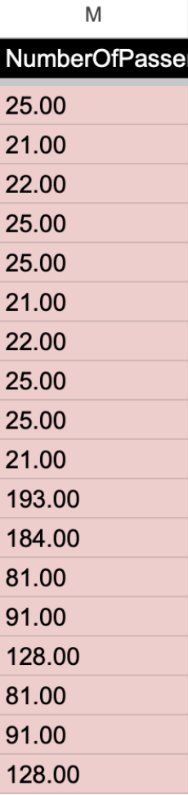

**Defect Address (Resolution Description):** went through all data entered and changed how sum was calculated in the passenger row so the sum was right.

**File Name: Database Flight Table**

**Bug/ Defect Number:** 37

**Contractor:** Alexandra Hall

**Date:** April 10, 2024

**Time of Defect:** 3:25pm

**Defect Description:** script for database passenger did not need to read in passenger density just number of passengers on the flight. Leading to the price per flight being off by several thousand. The Numbers were wrong and most were single digits.

**Defect Address (Resolution Description):** addressed by creating a different value and a different file with only flight number and number of passengers listed.

**File Name: Database Flight Table**

**Bug/ Defect Number:** 38

**Contractor:** Alexandra Hall

**Date:** April 10, 2024

**Time of Defect:** 3:25pm

**Defect Description:** Flight database sheet for the .csv file had the wrong format for dates that the database could not read in properly.

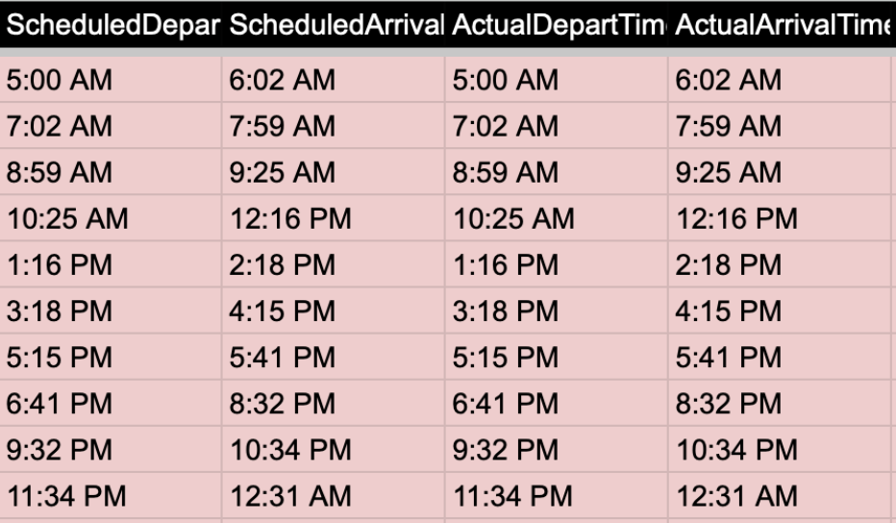

**Defect Address (Resolution Description):** Changed format without AM and PM to work with the format needed to run smoothing within the database.

**File Name:** Database Passenger Table

**Bug/ Defect Number:** 45

**Contractor:** Hanna Zelis

**Date:** April 14, 2024

**Time of Defect:** 2:23pm

**Defect Description:** After filling out the flightNumbers in the passenger table, we realized that we had generated too many passengers, as the total number of passengers we had created was about 103,000 while in reality, our planes for 14 days only ended up developing between 99,000 to 100,000 passengers

**Defect Address (Resolution Description):** Redo the flightNumber assignment to passengers to ensure that there was one person per ticket per flight for each flight all 14 days. For example, flight F1A only had 25 people on the flight, so the first 25 passengers under the passengerID side (P1-P25) were given flight F1A.

**File Name:** Database Flight Table

**Bug/ Defect Number:** 46

**Contractor:** Hanna Zelis

**Date:** April 14, 2024

**Time of Defect:** 2:28pm

**Defect Description:** After filling out the flightNumbers in the flight table, we realized that we had generated some flights without implementing the “A”, “B”, or “C” at the end. It was caught when trying to push the flight table into the database and it was causing formatting errors. It was for flights F710, F711 and F712.

**Defect Address (Resolution Description):** We went back into the flight table and added “A” and “B” as accordingly for that route and day, which resulted in flightNumbers F710A, F711A, F712A, F710B.

**File Name:** Database Flight Table

**Bug/ Defect Number:** 47

**Contractor:** Hanna Zelis

**Date:** April 14, 2024

**Time of Defect:** 3:02pm

**Defect Description:** After filling out the flightNumbers in the flight table, we realized that we had generated some flights without implementing the “A”, “B”, or “C” at the end. It was caught when trying to push the flight table into the database and it was causing formatting errors. It was for flights F797 and F798.

**Defect Address (Resolution Description):** We went back into the flight table and added “A” and “B” as accordingly for that route and day, which resulted in flightNumbers F797A, F797B, F797C, F798A, and F798B.

**File Name:** Database Flight Table

**Bug/ Defect Number:** 48

**Contractor:** Hanna Zelis

**Date:** April 14, 2024

**Time of Defect:** 3:05 pm

**Defect Description:** When originally generating the database flight table, the ScheduledDepartTime, ScheduledArrivalTime, ActaulDepartTime, ActualArrivalTime originally had the formatting of mm-dd-yyyy, however, Joellen noted that the GUI automatically needs the format of yyyy-mm-dd.

**Defect Address (Resolution Description):** We went back into the flight table and rewrote all of the dates in the new format as it was easier to just change the format of all of the airplane flights than try to risk altering the code and creating bugs where not necessary.

**File Name:** Database Flight Table

**Bug/ Defect Number:** 50

**Contractor:** Hanna Zelis

**Date:** April 14, 2024

**Time of Defect:** 4:00pm

**Defect Description:** When reading the 14 days of requirements, we recognized that there were a few different types of delays, whether that was delaying the flight at the gate or extending the flight time, causing delays for the flights the rest of the day. Because of this, we originally had the delay at the beginning of the flight for day 3, resulting in incorrect implementation of day 3’s delays.

**Defect Address (Resolution Description):** We had to go back and start the first set of flights for all routes to be at normal times but keep the end delayed time, allowing for the extension of flight time but not creating an at gate delay.

**File Name:** home page of the GUI (which is the “Airport Timetable” tab)

**Bug/ Defect Number:** 49

**Contractor:** Hanna Zelis

**Date:** April 14, 2024

**Time of Defect:** 3:13 pm

**Defect Description:** Basically, when we added the ability for the language to be changed from English to French, it generated all French when entering minus the pop up boxes for the flight numbers where it was hours and minutes.

**Defect Address (Resolution Description):** Altered the GUI code where we converted the language from English to French to display hours and minutes in the flight number pop up box in French

**File Name:** Database Flight Table

**Bug/ Defect Number:** 51

**Contractor:** Hanna Zelis

**Date:** April 14, 2024

**Time of Defect:** 6:57pm

**Defect Description:** When reviewing the delayed flights, we noticed flight F863A and flight F864A had 0 for the distance and passenger density. However, we didn’t think we had to include that data for the canceled flights, but then we recognized that not filling in those data points with numbers could interrupt the GUI.

**Defect Address (Resolution Description):** After realizing it could impact the GUI, we put 22 and 23 for passenger density for flights correspondingly and a distance of 1715.88 for both flights.

**File Name:** Database Flight Table

**Bug/ Defect Number:** 52

**Contractor:** Hanna Zelis

**Date:** April 14, 2024

**Time of Defect:** 7:37pm

**Defect Description:** When reviewing the delayed flights, we noticed flight F867A and flight F868A had 0 for the distance and passenger density. However, we didn’t think we had to include that data for the canceled flights, but then we recognized that not filling in those data points with numbers could interrupt the GUI.

**Defect Address (Resolution Description):** After realizing it could impact the GUI, we put 8 and 8 for passenger density for flights correspondingly and a distance of 1246.77 for both flights.

**File Name:** Passenger Table in Database

**Bug/ Defect Number:** 55

**Contractor:** Hanna Zelis

**Date:** April 14, 2024

**Time of Defect:** 8:23pm

**Defect Description:** The data was originally put into the passengerID with a weird syntax, making it difficult to be put into the database, with the original syntax being (‘P1.

**Defect Address (Resolution Description):** Because of the weird syntax, we changed the passengerID to be P1, P2, and so forth, without the weird quotation marks and parentheses.

**File Name:** Passenger Table in Database

**Bug/ Defect Number:** 56

**Contractor:** Hanna Zelis

**Date:** April 14, 2024

**Time of Defect:** 8:25pm

**Defect Description:** The data was originally put into the flightNumber with a weird syntax, making it difficult to be put into the database, with the original syntax being ‘, ‘F1A’),.

**Defect Address (Resolution Description):** Because of the weird syntax, we changed the flightNumber to be F1A, F1B,, and so forth, without the weird quotation marks, parenthese, and commas.

**File Name:** Aircraft Table in Database

**Bug/ Defect Number:** 58

**Contractor:** Hanna Zelis

**Date:** April 14, 2024

**Time of Defect:** 8:57 pm

**Defect Description:** The aircraft B7378-4 had the incorrect TotalSeats value, as it had the TotalSeats value of the B7474-1 rather than the B7378

**Defect Address (Resolution Description):** We changed the seats back to what it was supposed to be, but if it had stayed, it could have messed up the GUI and other equations that impact our revenue, so we changed it back from 398 to 156.

**File Name:** index.php

**Bug/ Defect Number:** 59

**Contractor:** Joellen Allah-Mensah

**Date:** April 5, 2024

**Time of Defect:** 2:03 PM

**Defect Description:** Multiple PHP lines were missing semicolons, causing a syntax error that prevented the script from executing. This was particularly prevalent in the sections where session variables were set.

**Defect Address (Resolution Description):** Added semicolons to end each statement to correct PHP syntax. For example, corrected $_SESSION['language'] = $_POST['language'] to $_SESSION['language'] = $_POST['language'];.

**File Name:** index.php

**Bug/ Defect Number:** 60

**Contractor:** Joellen Allah-Mensah

**Date:** April 6, 2024

**Time of Defect:** 9:15 AM

**Defect Description:** The script did not handle database connection failures gracefully, often leading to a blank screen without any error message, confusing users when the database connection failed.

**Defect Address (Resolution Description):** Implemented a user-friendly error message and used die() to stop script execution. Added the following code: if (!$connect) { die("Connection failed: " . mysqli_connect_error()); }.

**File Name:** index.php

**Bug/ Defect Number:** 61

**Contractor:** Joellen Allah-Mensah

**Date:** April 6, 2024

**Time of Defect:** 11:42 AM

**Defect Description:** Misuse of the assert() function for database connection checks led to unexpected script termination without any fallback or error handling mechanism.

**Defect Address (Resolution Description):** Replaced assert() with conditional error checks and handled the error properly to avoid abrupt script termination. Changed to: if (!$connect) { echo "Connection error: " . mysqli_connect_error(); exit(); }.

**File Name:** index.php

**Bug/ Defect Number:** 62

**Contractor:** Joellen Allah-Mensah

**Date:** April 7, 2024

**Time of Defect:** 4:58 PM

**Defect Description:** Data output to the page was not being escaped, exposing the site to cross-site scripting (XSS) attacks whenever user-generated content was displayed on the page.

**Defect Address (Resolution Description):** Added htmlspecialchars() function to all outputs that may include user input or database content. For example, changed echo $data to echo htmlspecialchars($data, ENT_QUOTES, 'UTF-8');.

**File Name:** index.php

**Bug/ Defect Number:** 63

**Contractor:** Joellen Allah-Mensah

**Date:** April 8, 2024

**Time of Defect:** 10:17 AM

**Defect Description:** Attempting to access $_SESSION['language'] without ensuring it was set first resulted in PHP notices about undefined indexes which could lead to logic errors in multilingual support.

**Defect Address (Resolution Description):** Implemented isset() to check if the session variable is set before using it, reducing error notices and improving code reliability. Implemented as: if (!isset($_SESSION['language'])) { $_SESSION['language'] = 'en'; }.

**File Name:** index.php

**Bug/ Defect Number:** 64

**Contractor:** Joellen Allah-Mensah

**Date:** April 8, 2024

**Time of Defect:** 1:45 PM

**Defect Description:** The modal content was static due to incorrect JavaScript logic that did not properly update the DOM elements with dynamic content based on user interactions.

**Defect Address (Resolution Description):** Revised the JavaScript function to correctly handle dynamic data insertion into the modal. Updated the function to: document.querySelector('#modal-content-text').innerHTML = generateModalContent(departureAirport, destinationAirport);.

**File Name:** index.php

**Bug/ Defect Number:** 65

**Contractor:** Joellen Allah-Mensah

**Date:** April 9, 2024

**Time of Defect:** 3:30 PM

**Defect Description:** Stylesheets were not loading due to incorrect relative paths in the HTML link tags, resulting in unstyled content appearing on the page.

**Defect Address (Resolution Description):** Corrected the file paths in the <link> tags to ensure CSS files are correctly linked and styles are applied as expected. Corrected path: <link rel="stylesheet" type="text/css" href="/css/main.css">.

**File Name:** repo.php  
**Bug/ Defect Number:** 66  
**Contractor:** Joellen Allah-Mensah  
**Date:** April 9, 2024  
**Time of Defect:** 10:15 AM  
**Defect Description:** The database query failed to execute due to incorrect parameter binding, causing an error that prevented the fetching of unique tail numbers from the database.  
**Defect Address (Resolution Description):** Corrected the parameter binding in the mysqli_stmt_bind_param function to ensure the data types matched the expected types in the database. For example, updated the code from mysqli_stmt_bind_param($stmt, "i", $tailNumber) to mysqli_stmt_bind_param($stmt, "s", $tailNumber) to correctly bind a string.

**File Name:** repo.php  
**Bug/ Defect Number:** 67  
**Contractor:** Joellen Allah-Mensah  
**Date:** April 10, 2024  
**Time of Defect:** 3:50 PM  
**Defect Description:** JavaScript error due to improper handling of asynchronous operations, leading to tabs not displaying report data immediately after data was supposed to be fetched.  
**Defect Address (Resolution Description):** Implemented an asynchronous function using AJAX to fetch data and then update the DOM only after the data is fully loaded. Here’s the added code snippet:

async function fetchData() {

let response = await fetch('data_endpoint');

let data = await response.json();

updateDOM(data); }

**File Name:** repo.php  
**Bug/ Defect Number:** 68  
**Contractor:** Joellen Allah-Mensah  
**Date:** April 11, 2024  
**Time of Defect:** 1:27 PM  
**Defect Description:** The PHP script had an issue with an infinite loop caused by incorrect calculation of day offsets that exceeded the bounds of the data array.  
**Defect Address (Resolution Description):** Revised the loop condition to prevent exceeding the array limits and added checks to ensure the day offset did not cause an out-of-bounds error. Here's the corrected code for better boundary handling:

for ($day = 1; $day <= min(14, count($dayDetails)); $day++) {

$dayOffset = $day - 1;

...

}

**File Name:** repo.php  
**Bug/ Defect Number:** 69  
Contractor: Joellen Allah-Mensah  
**Date:** April 12, 2024  
**Time of Defect:** 8:45 AM  
**Defect Description:** The summary statistics on the report were not updating dynamically as expected when new reports were generated. The issue was related to caching old report data and not recalculating the summary data upon each request.  
**Defect Address (Resolution Description):** Implemented a solution to clear the previous data and recalculate the summary statistics whenever new data is fetched. Added a reset function to clear old data and recalculated the totals in the script. Here’s an example snippet used to reset data:

function resetData() {

global $totalFlightsOperated, $totalPassengersTransported, $totalHoursOperated;

$totalFlightsOperated = 0;

$totalPassengersTransported = 0;

$totalHoursOperated = 0;

}

// Call resetData before starting new report generation

resetData();

**File Name:** route.php  
**Bug/ Defect Number:** 70  
**Contractor:** Joellen Allah-Mensah  
**Date:** April 12, 2024  
**Time of Defect:** 11:00 AM  
**Defect Description:** The system failed to display the total distance and travel time for routes due to incorrect aggregation calculations in the PHP script. The total distance was always zero because the distance data was not being accumulated properly in the loop.  
**Defect Address (Resolution Description):** Corrected the loop for accumulating total distance and total travel time. Added proper type casting and initialization before the loop starts to ensure that values are accumulated correctly. Updated code snippet:

$totalDistance = 0.0; // Ensure it's a float

$totalTravelTime = 0; // Initialize correctly

foreach ($routesData as $route) {

$totalTravelTime += (strtotime($route['ActualArrivalTime']) - strtotime($route['ActualDepartureTime'])) / 60;

$totalDistance += (float)$route['Distance']; // Cast as float to e

**File Name:** route.php  
**Bug/ Defect Number:** 71  
**Contractor:** Joellen Allah-Mensah  
**Date:** April 13, 2024  
**Time of Defect:** 2:30 PM  
**Defect Description:** SQL injection vulnerability was identified within the route selection form. User inputs for 'from' and 'to' fields were inserted directly into the database query without proper sanitization or prepared statements, leading to potential security risks.  
**Defect Address (Resolution Description):** Implemented the use of prepared statements to handle user inputs safely and avoid SQL injection. Revised the SQL query to bind parameters instead of concatenating strings directly. Here's how the secure implementation was coded:

$stmt = mysqli_prepare($connect, $sql);

mysqli_stmt_bind_param($stmt, "ss", $from, $to);

mysqli_stmt_execute($stmt);

$result = mysqli_stmt_get_result($stmt);

**File Name:** route.php  
**Bug/ Defect Number:** 72  
**Contractor:** Joellen Allah-Mensah  
**Date:** April 14, 2024  
**Time of Defect:** 9:15 AM  
**Defect Description:** JavaScript errors occurred when trying to display route data on the map. The script attempted to use route data before it was fully loaded from the server, causing null reference errors in the map initialization function.  
**Defect Address (Resolution Description):** Ensured that the map initialization script runs only after the route data is fully loaded and available. Introduced an asynchronous pattern and deferred the map initialization to ensure all data is present. Example modification:

document.addEventListener('DOMContentLoaded', function() {

if (routesData && routesData.length > 0) {

initializeMap(routesData); // Function that handles map initialization

}

});

**File Name:** route.php  
**Bug/ Defect Number:** 73  
Contractor: Joellen Allah-Mensah  
**Date:** April 15, 2024  
**Time of Defect:** 4:50 PM  
**Defect Description:** The user interface failed to update dynamically when different routes were selected. The issue was due to the stale data not being cleared from the interface upon new searches, causing overlapping data displays.  
**Defect Address (Resolution Description):** Implemented a clear function that resets the form and clears previous search results from the display before a new search is initiated. Added a 'Clear Route' button to the interface that triggers this function. Here’s the relevant code snippet:

function clearRoute() {

document.querySelector('form').reset();

document.getElementById('routeDetails').innerHTML = ''; // Clear the previous details

// Additional logic to reset the map and other dynamic elements

}

**File Name:** route.php

**Bug/ Defect Number:** 74

**Contractor:** Joellen Allah-Mensah

**Date:** April 15, 2024

**Time of Defect:** 2:45 PM

**Defect Description:** The routes selected are supposed to be shown on the right on the map, but since adding a date to the sort it will not show the path.

**Defect Address (Resolution Description):** We decided to not allow the user to short by date, allowing the visualization to show. To make up for this we are sorting the listed flights by date and departure time.

**File Name:** main.css

**Bug/ Defect Number:** 75

**Contractor:** Joshua Thompson

**Date: April 15, 2024**

**Time of Defect:** 2:59 PM

**Defect Description:** The dropdowns used in our website appear fine on Mac OS, but on Windows OS the text is white on a white background. The text is still visible when you hover over it, but it makes it difficult when using Windows

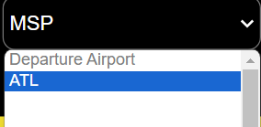

**Defect Address (Resolution Description):** We created a style sheet to handle and stop this from occurring.

**File Name:** calc.php

**Bug/ Defect Number:** 76

**Contractor:** Joshua Thompson

**Date:** April 15th, 2024

**Time of Defect:** 3:08 PM

**Defect Description:** The Calc.php web page seems to output all its calculations at the top before allowing you to view the section that it is supposed to be.

**Defect Address (Resolution Description):** The debug lines were not commented out, after commenting all of them out the bug was resolved.

// Debugging output

//echo "Processing: TailNumber = {$flight['TailNumber']}, DepartureDate = {$DepartureDate}, Rate = {$leasingRate}<br>";

**File Name:** comfort_airlines_byteme.sql

**Bug/ Defect Number:** 77

**Contractor:** Joshua Thompson

**Date:** April 15, 2024

**Time of Defect:** 3:10 PM

**Defect Description:** The structure of the .sql file is incredibly inefficient and needs to be optimized.

**Defect Address (Resolution Description):** After exporting the files, I was able to change the layout to be more readable.

**File Name:** Database Flight Table

**Bug/ Defect Number:** 78

**Contractor:** JR Vano

**Date:** April 12, 2024

**Time of Defect:** 2:37 pm

**Defect Description:** Time conversions based on time zones were wrong meaning a flight would have landed at an airport before it was able to

**Defect Address (Resolution Description):** Corrected the time zone difference allowing the flight to land within the 5 AM - 1 AM range.

**File Name:** calc.php

**Bug/ Defect Number:** 79

**Contractor:** Joshua Thompson

**Date:** April 15, 2024

**Time of Defect:** 3:17 PM

**Defect Description:** The calc.php file is not using our main style sheet, causing it to look out of place compared to our other pages.

**Defect Address (Resolution Description):** I import main.css so that it would look the same.

</style>

<link rel="stylesheet" type="text/css" href="main.css" />

**File Name:** calc.php

**Bug/ Defect Number:** 80

**Contractor:** Joellen Allah-Mensah

**Date:** April 15, 2024

**Time of Defect:** 3:27 PM

**Defect Description:** We currently are not factoring in the fuel cost for our Paris flight, and need to take that into consideration.

**Defect Address (Resolution Description):** We added our calculator for it, setting a condition to check to see if the flight is leaving Paris.

**File Name:** FlightTimes.csv

**Bug/ Defect Number:** 81

**Contractor:** Kyle Boan

**Date:** April 15, 2024

**Time of Defect:** 9:30pm

**Defect Description:** Multiple FlightNumber’s were mistyped and had the wrong number or letter attached

**Defect Address (Resolution Description):** Validate the correct FlightNumber and edit the file to reflect the validated data

**File Name:** Passenger.csv

**Bug/ Defect Number:** 82

**Contractor:** Kyle Boan

**Date:** April 15, 2024

**Time of Defect:** 9:30pm

**Defect Description:** During the creation of the file and incorrect number of passengers was added (103,115 instead of 103,067)

**Defect Address (Resolution Description):** Validated the correct number of passengers needed, rewrote the script, passengerCSV.py, ran the script and validated the correct output.

**File Name:** run.sh

**Bug/ Defect Number:** 83

**Contractor:** Kyle Boan

**Date:** April 15, 2024

**Time of Defect:** 9:35pm

**Defect Description:** Run script was not properly opening browser to show the gui.

**Defect Address (Resolution Description):** Added the following code to correctly open the browser and access the gui.  
*open -a "Google Chrome" http://localhost/index.php*

**File Name:** route.php

**Bug/ Defect Number:** 86

**Contractor:** Joellen Allah-Mensah

**Date:** April 15, 2024

**Time of Defect:** 4:43 PM

**Defect Description:** The route is having issues displaying

**Defect Address (Resolution Description):** I increased the limit on the ram to 256 mb/s and this solved the issue.

**File Name:** stop.sh

**Bug/ Defect Number:** 87

**Contractor:** Kyle Boan

**Date:** April 16, 2024

**Time of Defect:** 2:18pm

**Defect Description:** Needed script to stop the docker.

**Defect Address (Resolution Description):** Created script to stop the docker from running.

**File Name:** docker-compose.yml

**Bug/ Defect Number:** 92

**Contractor:** Kyle Boan

**Date:** April 16, 2024

**Time of Defect:** 1:16pm

**Defect Description:** The port used was sometimes used by other programs.

**Defect Address (Resolution Description):** Changed port 80 to port 8800 to avoid further errors caused by the port being in use.

**File Name:** Flight.csv

**Bug/ Defect Number:** 96

**Contractor:** Kyle Boan

**Date:** April 17, 2024

**Time of Defect:** 2:47pm

**Defect Description:** Flight.csv file did not include route numbers as part of the data set. This needed to be fixed.

**Defect Address (Resolution Description):** Edited the csv to correct for the error, adding the correct route numbers for each flight.

**File Name:** comfort_airlines_byteme.sql

**Bug/ Defect Number:** 97

**Contractor:** Kyle Boan

**Date:** April 17, 2024

**Time of Defect:** 2:50pm

**Defect Description:** The sql file creating the database needed to be updated to add the route numbers into the Flight table.

**Defect Address (Resolution Description):** Added the corrected create statement to fix the error.

**File Name:** calc.php

**Bug/ Defect Number:** 98

**Contractor:** Joshua Thompson

**Date:** April 17, 2024

**Time of Defect:** 3:20 PM

**Defect Description:** Ticket sales price was inaccurate and much higher than intended.

**Defect Address (Resolution Description):** Discovered we were not taking into account the market share, and after taking this into account the price is much more accurate.

**File Name:** index.php

**Bug/ Defect Number:** 99

**Contractor:** Joshua Thompson

**Date:** April 17, 2024

**Time of Defect:** 3:37 PM

**Defect Description:** Every flight has the incorrect time listed in our GUI for the flight duration in the pop up box.

**Defect Address (Resolution Description):** We added two columns to our flight database with EST as 0 and entered -1, -2, -3, and 6 to correspond to time zones and then calculated the equation by adding this component to departure time zone and arrival time zone

**File Name:** calc.php

**Bug/ Defect Number:** 100

**Contractor:** Kyle Boan

**Date:** April 17, 2024

**Time of Defect:** 6:39 PM

**Defect Description:** The profit should be positive with how we have things set up, but we are set to lose $17 million, which should not occur because our ticket price is changed to cover the price of everything, so we should not lose money.

**Defect Address (Resolution Description):** We found the error, we forgot to remove the prefix which was a -, making our calculations wrong.

**File Name:** calc.php

**Bug/ Defect Number:** 101

**Contractor:** Kyle Boan

**Date:** April 17, 2024

**Time of Defect:** 6:51 PM

**Defect Description:** The prices are still incorrect, while this previous defect made us go positive, we suddenly shot up 5 *BILLION*.

**Defect Address (Resolution Description):** We were calculating costs as if they were per day, but then our calculations themselves were per flight, causing the disparity. We also found that our operations cost was calculated for each day for every flight (this caused us to gain 70 billion). This was the problem that caused the biggest discrepancy.

**File Name:** calc.php

**Bug/ Defect Number:** 102

**Contractor:** JR Vano

**Date:** April 17, 2024

**Time of Defect:** 8:13 PM

**Defect Description:** Used cost per liter in Euros and did not convert to USD

**Defect Address (Resolution Description):** Calculated it in USD and changed in calc.php and index.php

**File Name:** calc.php

**Bug/ Defect Number:** 103

**Contractor:** JR Vano

**Date:** April 17, 2024

**Time of Defect:** 8:19 PM

**Defect Description:** Nautical Miles for Calculating Gallons per mile for paris right was not converted to miles

**Defect Address (Resolution Description):** Converted to miles and changed in calc.php

**File Name:** calc.php

**Bug/ Defect Number:** 104

**Contractor:** JR Vano

**Date:** April 17, 2024

**Time of Defect:** 8:27 PM

**Defect Description:** Revenue equation was incorrect because it was calculating for sum of each day rather than sum of each flight per day

**Defect Address (Resolution Description):** Changed the formula to sum of flights per day

**File Name:** calc.php

**Bug/ Defect Number:** 105

**Contractor:** JR Vano

**Date:** April 17, 2024

**Time of Defect:** 8:49 PM

**Defect Description:** In gallonspermile we had calculated for miles per gallon

**Defect Address (Resolution Description):** Recalculated all the math to account for gallonspermile

**File Name:** calc.php

**Bug/ Defect Number:** 106

**Contractor:** JR Vano

**Date:** April 17, 2024

**Time of Defect:** 9:19PM

**Defect Description:** For operational costs we were just setting it equal to to the cost per day rather than adding and setting it to that variable

**Defect Address (Resolution Description):** Changed + to += in operational costs calculation

**File Name:** flight,DB and docker

**Bug/ Defect Number:** 107

**Contractor:** JR Vano

**Date:** April 17, 2024

**Time of Defect:** 9:40PM

**Defect Description:** Missing inputted timezones for arrival and departure from the flight database file

**Defect Address (Resolution Description):** Had to add the time zones manually into the database